**Splunk Integration For Databricks**

Installation And Usage Guide 1.0.0

Note:

This document is produced by Databricks as a reference. Databricks makes no warranties or guarantees. Information contained within may not be the most up-to-date available. Information in this document is subject to change without notice. Databricks shall not be liable for any damages resulting from technical errors or omissions that may be present in this document, or from use of this document.

Databricks and the Databricks logo are trademarks or service marks of Databricks, Inc. in the US and other countries. Microsoft Azure and Azure are trademarks of Microsoft Inc. Azure Databricks is a product provided by Microsoft, please see their website for additional information. All other trademarks within this document are property of their respective companies. Copyright 2020 Databricks, Inc. For more information, visit [http://www.databricks.com](http://www.databricks.com/).

Technical documentation and support materials include details based on the full set of capabilities and features of a specific release. Access to some functionality requires specific license types (tiers).

Version Control

|  |  |  |  |  |  |
| --- | --- | --- | --- | --- | --- |
| **#** | **Document**  **Version** | **Date** | **Owner** | **Document Status** | **Comments** |
| 1 | 1.0.0 | 22nd Jan 2021 | Crest Data  Systems | Draft | Initial Draft |

**Overview** **4**

**Compatibility Matrix** **4**

**System Requirements** **4**

**Installation** **5**

**Configuration** **5**

Configure Proxy Details (Optional) 5

Configure Databricks Credentials 6

Configure Logging (Optional) 7

**Executing custom commands** **8**

databricksquery 8

databricksrun 9

databricksjob 10

**Dashboards** **10**

Databricks Job Execution Details 11

**Known Issues** **11**

**Limitations** **11**

**Troubleshooting** **12**

**Uninstall & Cleanup Steps** **13**

# Overview

Databricks is a unified data analytics platform used for processing and transforming massive quantities of data and exploring the data through machine learning models. It offers a data science workspace, SQL analytics, unified data service, and enterprise cloud services. For more details visit [here](https://databricks.com/product/unified-data-analytics-platform).

Splunk is a software platform that enables users to search, analyze, and visualize the data gathered from the components of their IT infrastructure or business. It takes in data from websites, applications, sensors, devices, and so on. After you define the data source, Splunk Enterprise indexes the data stream and parses it into a series of individual events that you can view and search. For more details visit [here](https://docs.splunk.com/Documentation/Splunk/8.1.1/Overview/AboutSplunkEnterprise).

With “Splunk Integration For Databricks”, users will be able to:

* Query their data present in Databricks delta table from Splunk
* Execute Databricks notebooks from Splunk

This integration will consist of mainly 2 things:

* A Splunk application that manages authentication with Databricks, provides custom commands to submit queries and jobs in Databricks.

# Compatibility Matrix

|  |  |  |
| --- | --- | --- |
| **Splunk Version** | **Operating System** | **Databricks API Version** |
| 8.0.x | CentOS, Ubuntu, Windows 10, Windows Server 2019 | * REST API 1.2 for command execution * REST API 2.0 for the rest of the features |
| 8.1.x | CentOS, Ubuntu, Windows 10, Windows Server 2019 | * REST API 1.2 for command execution * REST API 2.0 for the rest of the features |

# System Requirements

The system requirements for the Splunk integration are the same as the basic requirements of the Splunk deployment. ([Reference](https://docs.splunk.com/Documentation/Splunk/8.0.0/Capacity/Referencehardware))

# Installation

Based on your Splunk deployment, follow the steps mentioned below to install the Splunk applications:

* [Standalone Splunk Deployment](https://docs.splunk.com/Documentation/AddOns/released/Overview/Singleserverinstall)
* [Distributed Splunk Deployment](https://docs.splunk.com/Documentation/AddOns/released/Overview/Distributedinstall)

In case of deployment in the search head cluster environment use a deployer to push the apps. Follow the below steps to push the apps to search head cluster members:

* On deployer node, extract the app at $SPLUNK_HOME$/etc/shcluster/apps.
* Create a “shclustering” stanza at path $SPLUNK_HOME$/etc/shcluster/apps/TA-Databricks/local/server.conf and add following information to the stanza: conf_replication_include.ta_databricks_settings = true as shown below.  
    
  [shclustering]  
  conf_replication_include.ta_databricks_settings = true
* Push the bundle to search head members

If you are using “Distributed Splunk Deployment”, refer to the below table to find where to install which applications:

|  |  |
| --- | --- |
| **Splunk Instance Type** | **Databricks Add-on for Splunk Required?** |
| Heavy Forwarder | - |
| Indexer/Indexer Cluster | - |
| Search Head/Search Head Cluster | Yes |

# Configuration

Users will be required to have admin_all_objects capability in order to configure Databricks Add-on for Splunk. This integration allows a user to configure **only one pair** of Databricks Instance, Databricks Access Token and Databricks Cluster Name at a time. In case a user is using the integration in search head cluster environment, configuration on all the search cluster nodes will be overwritten as and when a user changes some configuration on any one of the search head cluster members. Hence a user should configure the integration on only one of the search head cluster members. Once the installation is done successfully, follow the below steps to configure:

## Configure Proxy Details (Optional)

**This step is only required if you want to use a proxy server**. To configure proxy details:

* Log in to Splunk UI.
* Go to the Configuration page, either by clicking on the name of the add-on on the left navigation banner on the home page or by going to Manage Apps, then clicking Launch app in the row for Databricks Add-on for Splunk.
* Click the Configuration menu and in the Proxy tab, fill in the required details. Refer to the below table to fill in the details.

|  |  |  |
| --- | --- | --- |
| **Input** | **Required** | **Description** |
| Enable | Yes | Whether to use proxy or not |
| Proxy Type | Yes | Type of proxy |
| Host | Yes | Proxy host |
| Port | Yes | Port to use |
| Username | No | Username to use for authentication |
| Password | No | Password for the provided username. |
| Remote DNS resolution | No | Whether to resolve DNS or not |

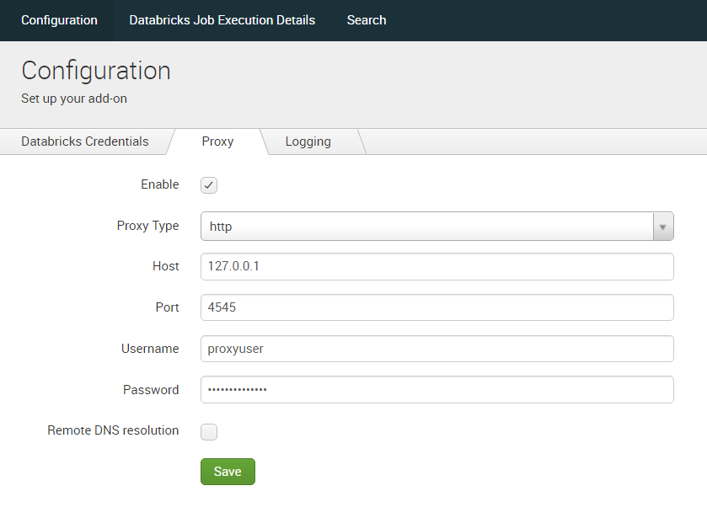

* Click Save.

## Configure Databricks Credentials

To configure Databricks credentials:

* Log in to Splunk UI.
* Go to the Configuration page, either by clicking on the name of the add-on on the left navigation banner on the home page or by going to Manage Apps, then clicking Launch app in the row for Databricks Add-on for Splunk.
* Click the Configuration menu and in the Databricks Credentials tab, fill in the required details. Refer to the below table to fill in the details.

|  |  |  |
| --- | --- | --- |
| **Input** | **Required** | **Description** |
| Databricks Instance | Yes | URL of Databricks instance to be used.  Ex: community.cloud.databricks.com |
| Databricks Access Token | Yes | Databricks personal access token to use for authentication.  Refer “[Generate Databricks Access Token](https://docs.databricks.com/dev-tools/api/latest/authentication.html#generate-a-personal-access-token)” document to generate the access token. |
| Databricks Cluster Name | No | Name of the Databricks cluster to use for notebook and query execution. |

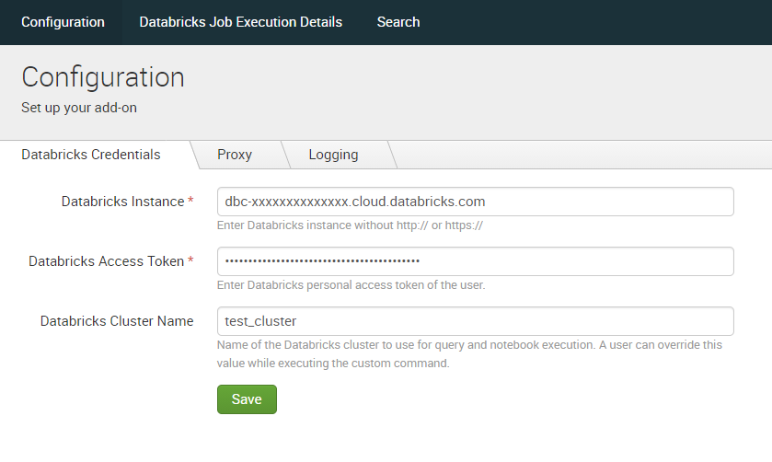

* Click Save.

**Note:** For validation of the parameters provided, the application will try to get the clusters present in the Databricks instance.

## Configure Logging (Optional)

To configure Logging:

* Log in to Splunk UI.
* Go to the Configuration page, either by clicking on the name of the add-on on the left navigation banner on the home page or by going to Manage Apps, then clicking Launch app in the row for Databricks Add-on for Splunk.
* Click on the Configuration menu and in the Logging tab, select appropriate Log Level from dropdown.
* Click Save.

# Executing custom commands

Users will be required to have admin_all_objects or list_storage_passwords capability in order to execute the custom command. Once the user configures Databricks Add-on for Splunk successfully, they can execute custom commands. With custom commands, users can:

* Query their data present in the Databricks table from Splunk.
* Execute Databricks notebooks from Splunk.

Currently, Databricks Add-on for Splunk provides three custom commands. Users can open the Splunk search bar and can execute the commands. Below are the command details.

## databricksquery

This custom command helps users to query their data present in the Databricks table from Splunk.

* **Command** **Parameters**

|  |  |  |
| --- | --- | --- |
| **Parameter** | **Required** | **Overview** |
| query | Yes | SQL query to get data from Databricks delta |
| cluster | No | Name of cluster to use for execution |
| command_timeout | No | Time to wait in seconds for query completion. Default value: 300 |

* **Syntax**  
    
  *| databricksquery cluster=”<cluster_name>” query=”<SQL_query>” command_timeout=<timeout_in_seconds> | table \**
* **Output**The command will give the output of the query in tabular format. It will return an error message in case of an error occurs in query execution.
* **Example**| databricksquery query=”SELECT * FROM default.people WHERE age>30” cluster=”test_cluster” command_timeout=60 | table *
* **Note**The Databricks API used in the databricksquery custom command has a limit on the number of results to be returned. Hence, sometimes the results obtained from this custom command may not be complete. In that case, a warning will be shown saying “Results are truncated due to Databricks API limitations.”

## databricksrun

This custom command helps users to submit a one-time run without creating a job.

* **Command Parameters**

|  |  |  |
| --- | --- | --- |
| **Parameter** | **Required** | **Overview** |
| notebook_path | Yes | The absolute path of the notebook to be run in the Databricks workspace. This path must begin with a slash. |
| run_name | No | Name of the submitted run |
| cluster | No | Name of cluster to use for execution |
| revision_timestamp | No | The timestamp of the revision of the notebook. |
| notebook_params | No | Parameters to pass while executing the run. In the form of “key1=value1||key2=value2||...” |

* **Syntax**  
    
  *| databricksrun notebook_path=”<path_to_notebook>” run_name=”<run_name>” cluster=”<cluster_name>” revision_timestamp=<revision_timestamp> notebook_params=”<params_for_job_execution>” | table \**
* **Output**

The command will give the details about the executed run through the job.

* **Example 1**

| databricksrun notebook_path=”/path/to/test_notebook” run_name=”run_comm” cluster=”test_cluster” revision_timestamp=1609146477 notebook_params=”key1=value1 || key2=value2” | table *

* **Example 2**

| databricksrun notebook_path=”/path/to/test_notebook” run_name=”run_comm” cluster=”test_cluster” revision_timestamp=1609146477 notebook_params=”key1=value with \”double quotes\” in it||key2=value2” | table *

## databricksjob

This custom command helps users to run an already created job now from Splunk.

* **Command Parameters**

|  |  |  |
| --- | --- | --- |
| **Parameter** | **Required** | **Overview** |
| job_id | Yes | Job ID of your existing job in Databricks |
| notebook_params | No | Parameters to pass while executing the job. In the form of “key1=value1||key2=value2||...” |

* **Syntax**  
    
  *| databricksjob job_id=<job_id> notebook_params=”<params_for_job_execution>” | table \**
* **Output**  
    
  The command will give the details about the executed run through the job.
* **Example 1**| databricksjob job_id=2 notebook_params=”key1=value1 || key2=value2” | table *
* **Example 2**

| databricksjob job_id=2 notebook_params=”key1=value with \”double quotes\” in it||key2=value2” | table *

# Dashboards

Users can check the status of command execution in the dashboard. Dashboard will be accessible to all the users. A user with admin_all_objects capability can navigate to “<splunk_instance_host_or_ip>:<splunk_web_port>/en-US/app/TA-Databricks/dashboards” to modify the permissions for “Databricks Job Execution Details” dashboard. This app contains the following dashboard:

## Databricks Job Execution Details

The dashboard provides the details about the one-time runs and jobs executed using databricksrun and databricksjob custom commands respectively.

To view the dashboard:

* Log in to Splunk UI.
* Go to the Databricks Job Execution Details page, either by clicking on the name of the add-on on the left navigation banner on the home page or by going to Manage Apps, then clicking Launch app in the row for Databricks Add-on for Splunk.
* Select appropriate values from the dropdown and the tables will be displayed.
* Click on any record to go to that particular job page.

# Known Issues

When the commands fail, sometimes an indistinct/unclear error message is displayed in UI, not giving a precise reason for the failure. To troubleshoot such cases, please check the logs at $SPLUNK_HOME/var/log/TA-Databricks/<command_name>_command.log to get the precise reason for the failure.

# Limitations

The Databricks API used in the databricksquery custom command has a limit on the number of results to be returned. Hence, sometimes the results obtained from this custom command may not be complete. In that case, a warning will be shown saying “Results are truncated due to Databricks API limitations.”

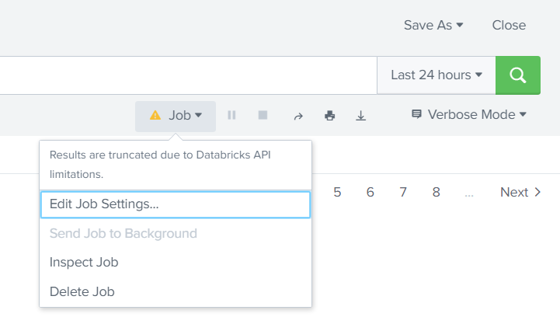

# Troubleshooting

* Instance URL should not start with scheme: Provide a Databricks instance without HTTP/HTTPS scheme. HTTPS scheme will be hard-coded before making any network calls.
* Unable to request Databricks instance. Please validate the provided Databricks and Proxy configurations or check the network connectivity.
* Invalid access token. Please enter the valid access token: Provided Access token is not a valid token. Please verify the token.
* Addon is not configured. Navigate to addon's configuration page to configure the addon.
* Error in SQL statement. AnalysisException. Table or view not found: You have entered invalid table name or invalid database name.
* API limit exceeded. Please try again after some time: You have made too many requests and the API limit has been exceeded.
* MaxContextException: Too many execution contexts are open right now: You have requested too many executions. Please try again after some time.
* Ensure that the cluster is in running state. Current cluster state is {Terminated/Pending}
* No cluster found with name {cluster_name}. Provide a valid cluster name.
* Given job does not contain the notebook task. Hence terminating the execution.
* Databricks cluster is required to execute this custom command. Provide a cluster parameter or configure the cluster in the TA's configuration page.
* Could not complete the query execution. Status {Cancelled/Error}: Submitted SQL query could not complete the execution on Databricks instance and returned error.
* Encountered unknown result type, terminating the execution: The SQL query returned something else other than the tabular result, which cannot be parsed by Splunk.
* Command execution timed out: The SQL query could not return anything. Try re-running the command after increasing value for command_timeout parameter.
* For any other unknown failure, please check the $SPLUNK_HOME/var/log/TA-Databricks folder to get more details on the issue.

Note: $SPLUNK_HOME denotes the path where Splunk is installed. Ex: /opt/splunk

# Uninstall & Cleanup Steps

* Remove $SPLUNK_HOME/etc/apps/TA-Databricks/
* Remove $SPLUNK_HOME/var/log/TA-Databricks/
* Remove $SPLUNK_HOME/var/log/splunk/ta_databricks.log
* To reflect the cleanup changes in the UI, restart Splunk instance. Refer https://docs.splunk.com/Documentation/Splunk/8.0.6/Admin/StartSplunk documentation to get information on how to restart Splunk.

Note: $SPLUNK_HOME denotes the path where Splunk is installed. Ex: /opt/splunk